Java Cookbook: Learn how to make Java Programs

Java Programming Recipes:

Recipe 1: How to do Programming with Java:

You could use a professional Grade Integrated Development Environment:

Eclipse

NetBeans

You could use an Online IDE.

(Peter’s Preferred Favorite way of doing it:) Good text editor (I like Sublime) and you need the Java Development Kit.

What is the JDK?

It is 2 things:

|  |
| --- |
| The JDK includes a Program for running Java Code on your computer. |
| It is a set of Libraries of Java Code that we use in our own Programs. |

Related Skills:

Command line terminal in our Operating System (Power Shell)

Database skills: one example is: SQLite

Basic Operating System Skills :

Working with the File System (Reading and writing files)

Operating System Processes

Scenario 1: How to make the simplest Java Program:

Open Command Prompt: Verify Java is there!

Start by making a Directory to work in:

make directory command: mkdir

change into that directory : chdir

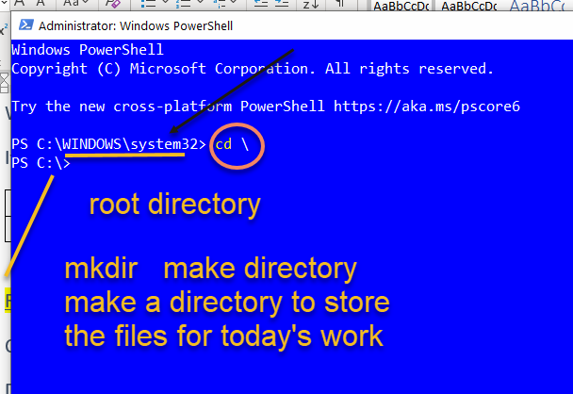

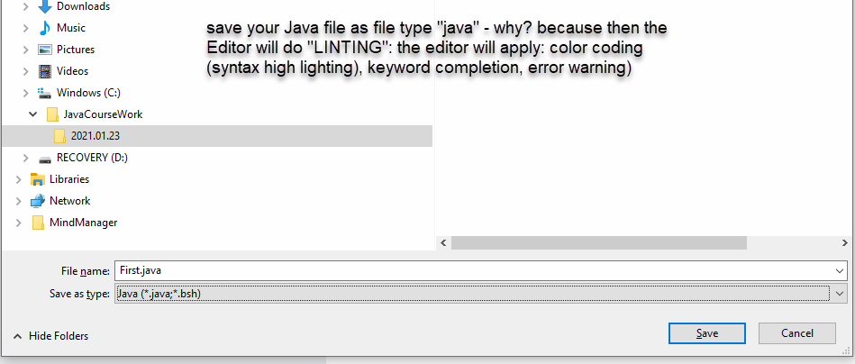

Comparing doing programming in a simple editor versus Eclipse:

For beginners: use a simple text editor!

Eclipse: gives you visual debugger, code management, integrated testing (JUNIT for example)

A couple of rules we need to use to write our Simplest Java Program:

A Java Program is written in a Text File with an extension of .java

You can many text files all containing the code for one program. (When you have programs that span across many file: then you really want a Professional IDE like Eclipse to do Code management).

All your code must be contained in OBJECTS.

You need at least 1 CLASS – and that class must be public named the same as the FILE that is containing it.

Recipe 2: How to Make OBJECTS:

The first thing to understand about Java Objects:

The Java Programming Language is another way of saying: The Java Runtime Environment

We “RUN” a program: Because we put the code into the CPU of the Computer.

**Recipe 10: Understanding Visibility Modifiers:**

**In Java, we are programming with OBJECTS: Objects contain Methods and Data Fields**

**public class**

**Java’s visibility Modifiers relate to the programming pattern of encapsulation.**

**Visibility Modifiers are the way to protect our code from being messed up!**

Recipe 11: **THE OBJECT ORIENTED PROGRAMMING PARADIGM WANT OBJECTS TO BE 3 THINGS:**

|  |  |
| --- | --- |
| Encapsulation | Keep things hidden.  Imagine a car engine: it displays encapsulation. The car engine is locked away from the driver:  Except through some well-defined Interfaces:   * Steering Wheel * Break Pedal * Accelerator Pedal   Those are out Interfaces (connectors) to the Car Engine: these can be considered as METHDs that let us interact with the METHOD of our Car Engine! |
| Abstraction/Inheritance |  |
| Polymorphism |  |